Advanced Higher Maths Review page 66
I’ll provide written solutions during the next lesson.
- Mistake in text book answer
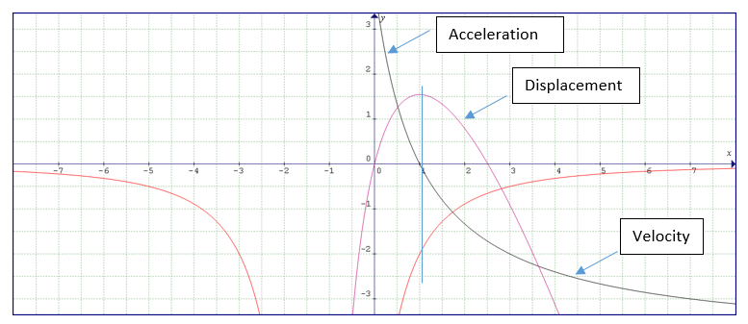
(Displacement –purple velocity – blue acceleration – red)
Acceleration = -2 units/sec² Displacement = 1.55 units

I used Graphmatica to confirm the correct answers. I highly recommend this free download.

- Quite a difficult problem, but excellent revision. You will have to use synthetic division to factorise the derivative (a cubic function) and then use the quadratic equation to find the roots for the remaining trinomial. Although there is a local maximum, there is no global one.
It’s certainly NOT 18, as the book answers suggest!! Another mistake I’m afraid.
So, I got a global min of x=-0.64. You should get another min of 0.39 and compare the y coordinates to see that x=0.64 is the global one. (Local max at x=1).
- Book answers correct on this one. This problem is straight forward.
- The problem is too difficult because so little information is given. The book answer, however, cannot be correct… think about it…. X cannot be 2/3L… Impossible.

If the base is a square then it’s easy.. , x=L/6, otherwise too complicated and not worth the time, although it can be done.

